Exploring Single Component Emulsifier for Bispyribac 10% SC: Enhancing Stability and Dispersion

Introduction: Emulsifier which play a crucial role in agricultural formulations, especially in herbicides like Bispyribac 10% SC. This newsletter aims to develop into the realm of single component emulsifier, focusing on their potential application in improving the stability and dispersion of Bispyribac 10% SC. By understanding the benefits and characteristics of these emulsifiers, farmers and agrochemical manufacturers can make informed decisions to optimize the performance of their formulations.
Understanding Single Component Emulsifier: Single component emulsifier refer to emulsifying agents that can create stable emulsions without the need for additional components. In the case of Bispyribac 10% SC, non-ionic emulsifiers such as alkyl polyglycoside and ethoxylated fatty alcohols are commonly utilized. These emulsifiers possess surface-active properties that enable them to disperse the active ingredient evenly throughout the formulation, preventing phase separation and improving long storage stability.
Benefits of Single Component Emulsifier: Using a single component emulsifier offers several advantages. Firstly, it simplifies the formulation process by eliminating the need for multiple emulsifiers. This saves time, resources, and reduces the risk of compatibility issues. Secondly, it enhances the stability of the formulation, preventing sedimentation and creaming. Stable emulsions ensure that the active ingredient remains uniformly distributed, thus providing consistent efficacy during application. Lastly, single component emulsifiers improve the dispersion of the herbicide, enabling better coverage and absorption by the target plants.
Optimizing Formulation Performance: When selecting a single component emulsifier for Bispyribac 10% SC, it is essential to consider factors such as the chemical compatibility with the active ingredient, environmental concerns, and availability. Natural-based emulsifiers like lecithin derived from soybeans offer an eco-friendly alternative without compromising performance. They possess excellent emulsifying properties and can contribute to the overall stability and dispersibility of the formulation. Additionally, conducting compatibility tests and consulting with experts can further aid in optimizing the emulsifier selection, ensuring a successful formulation.
Unitop Chemicals offers single component emulsifier suitable for Bispyribac 10% SC formulation. Our recommended emulsifiers is UNITOP BIPS-2301.
UNITOP BIPS-2301 is a non-ionic emulsifier specifically designed to stabilize suspension concentrates like Bispyribac 10% SC. It is a single component emulsifier that simplifies the formulation process. With its excellent emulsifying properties, it ensures the uniform dispersion of the active ingredient throughout the formulation.

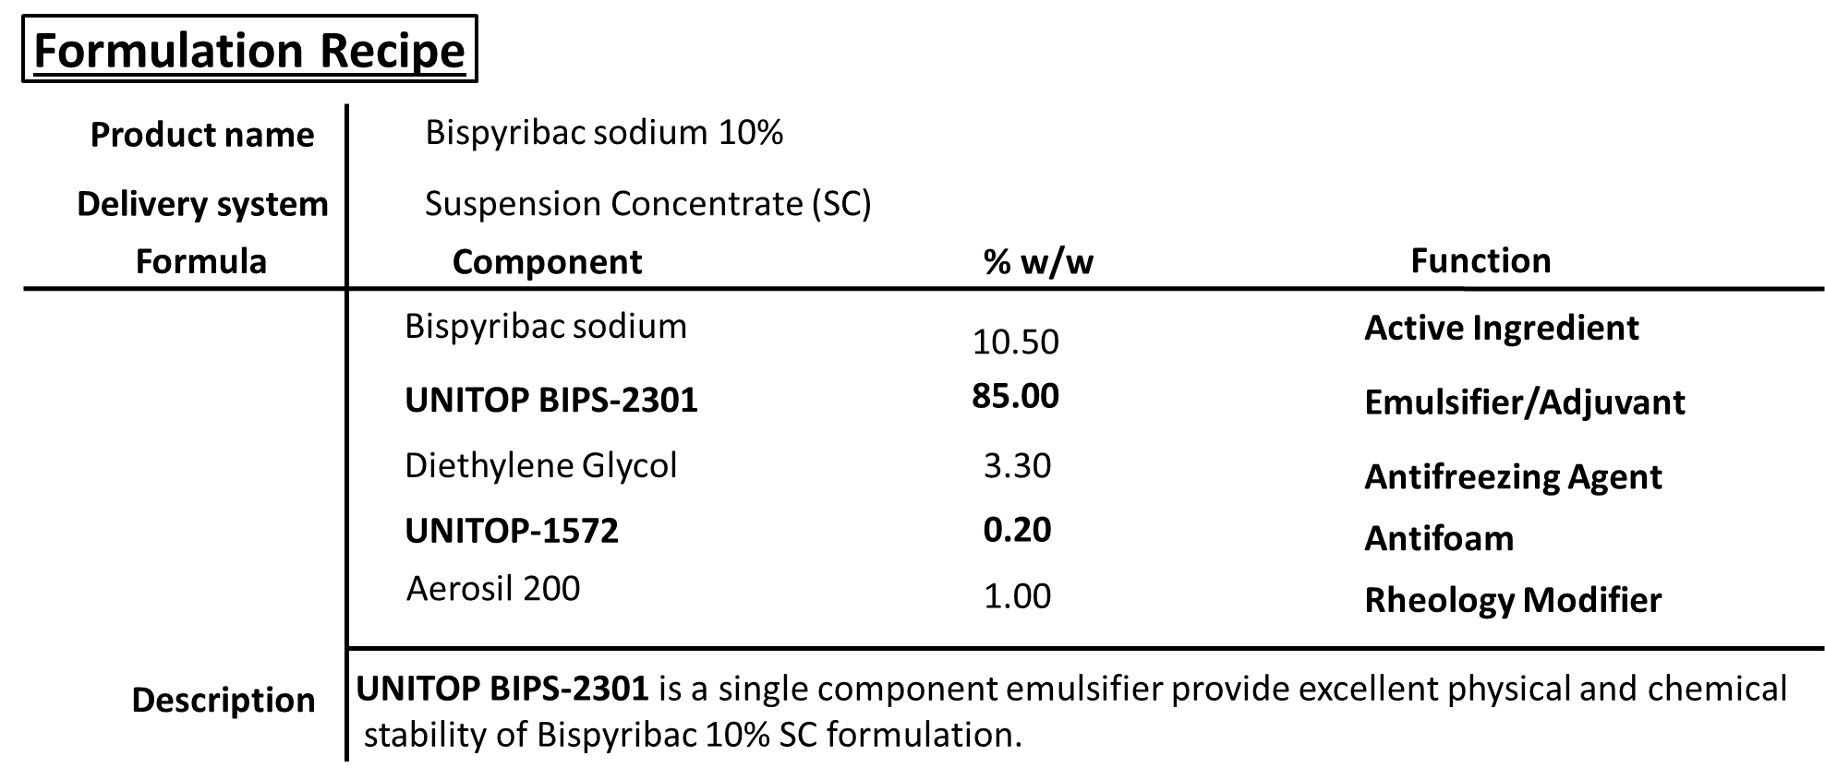
This emulsifier enhances the stability of Bispyribac 10% SC, preventing phase separation, and improving shelf life. It also aids in the formation of fine droplets, leading to better coverage and absorption by target plants.
UNITOP BIPS-2301 is known for its compatibility with a wide range of agrochemicals, making it a versatile choice for formulators. Additionally, it is designed to be environmentally friendly, meeting regulatory standards and ensuring sustainable agriculture practices.
When using UNITOP BIPS-2301, it is important to follow the recommended usage rates provided by Unitop Chemicals and conduct compatibility tests to ensure optimal performance.
Unitop Chemicals aims to provide high-quality emulsifiers that meet the specific needs of the agricultural industry. Their expertise in emulsion technology makes them a trusted choice for formulators seeking effective single component emulsifiers for Bispyribac 10% SC and other agricultural formulations.

